Java Basic

1. **Class**: The class is a blueprint (plan) of the instance of a class (object). It can be defined as a logical template that share common properties and methods.
2. **Object**: The object is an instance of a class. It is an entity that has behavior and state.
3. **Method**: The behavior of an object is the method i.e a method is a block of code that performs a specific task when called or invoked.
4. **Variables:-** A variable that holds data of specific data type.

Some Standard that we need to follow

**Class Names**:

Class names should be noun.

Start each word in the class name with an uppercase letter.

Class names should be descriptive and reflect the purpose or nature of the class.

Example: Car, StudentRecord, Calculator

class MyProgram // valid syntax

class 1Program // invalid syntax

class My1Program // valid syntax

class $Program // valid syntax, but discouraged

class My$Program // valid syntax, but discouraged

class myJavaProgram // valid syntax, but discouraged

**Variable Names**:

Variable names should be written in lowerCamelCase.

Start with a lowercase letter, and subsequent words are capitalized.

Variable names should be descriptive and reflect the purpose or meaning of the variable.

Example: firstName, totalAmount, numberOfStudents

**Constants**:

Constants should be written in uppercase letters.

Words are separated by underscores _.

Constants are often declared as static final and should be declared at the class level.

Constants should be meaningful and provide a hint about their purpose.

Example: MAX_VALUE, PI, DEFAULT_TIMEOUT

**Method Names**:

Method names should be written in lowerCamelCase.

Start with a lowercase letter, and subsequent words are capitalized.

Method names should be verbs or verb phrases that describe the action or behavior performed by the method.

Method names should be descriptive and indicate what the method does.

Example: calculateTotal, getUserInfo, printReport

**Package Names**:

Package names should be written in lowercase letters.

Use a reversed domain name (in lowercase) as the prefix to avoid naming conflicts.

Package names should be simple and meaningful, reflecting the content of the package.

Example: com.example.myproject, org.company.projectname

**Comments**

There are 3 types of comments available

1. Single line
2. Multiline
3. Documentation

**Case-sensitive**

Java is a case-sensitive language, which means that the identifiers AB, Ab, aB, and ab are different in Java.

System.out.println("GeeksforGeeks"); // valid syntax

system.out.println("GeeksforGeeks"); // invalid syntax

**public static void main(String [] args)**

The method main() is the main entry point into a Java program; this is where the processing starts.

**Java Keywords**-

| abstract | assert | boolean | break |
| --- | --- | --- | --- |
| byte | case | catch | char |
| class | const | continue | default |
| do | double | else | enum |
| extends | final | finally | float |
| for | goto | if | implements |
| import | instanceof | int | interface |
| long | native | new | package |
| private | protected | public | return |
| short | static | strictfp | super |
| switch | synchronized | this | throw |
| throws | transient | try | void |
| volatile | while |  |  |

**Difference between print and println**

**Decision making and conditional statement**

If- if statement is the most simple decision-making statement.if a certain condition is true then a block of statements is executed otherwise not.

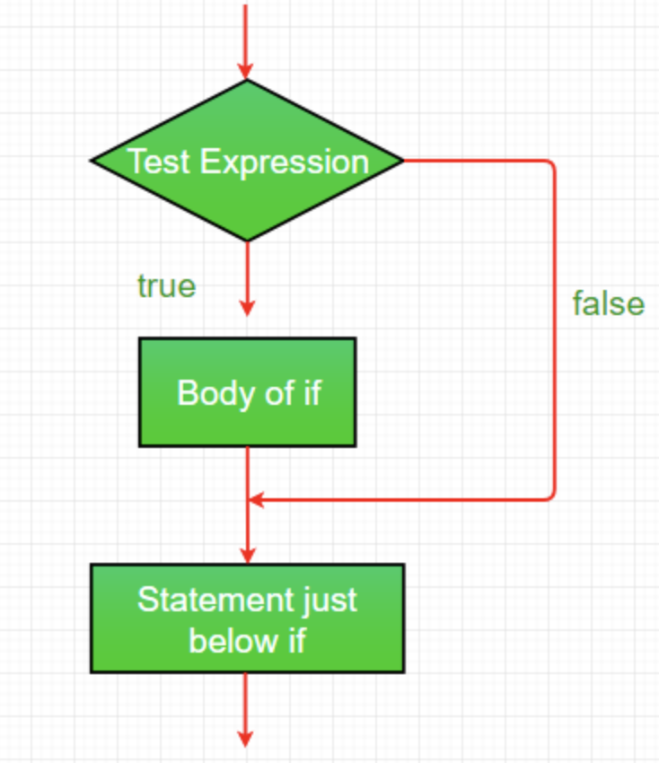

Syntax

if(condition)

{

// Statements to execute if

// condition is true

}

**If else**-if a certain condition is true then a block of statements is executed otherwise else block statements will execute.

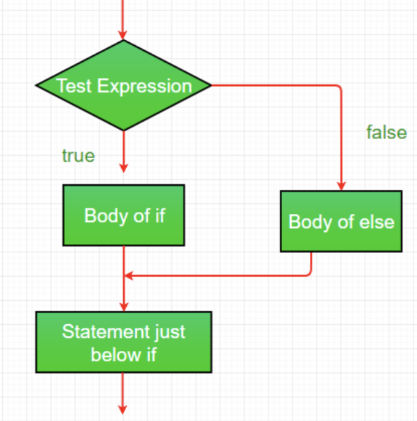

if (condition)

{

// Executes this block if

// condition is true

}

else

{

// Executes this block if

// condition is false

}

**Nested if:-** Nested if statements mean an if statement inside an if statement.

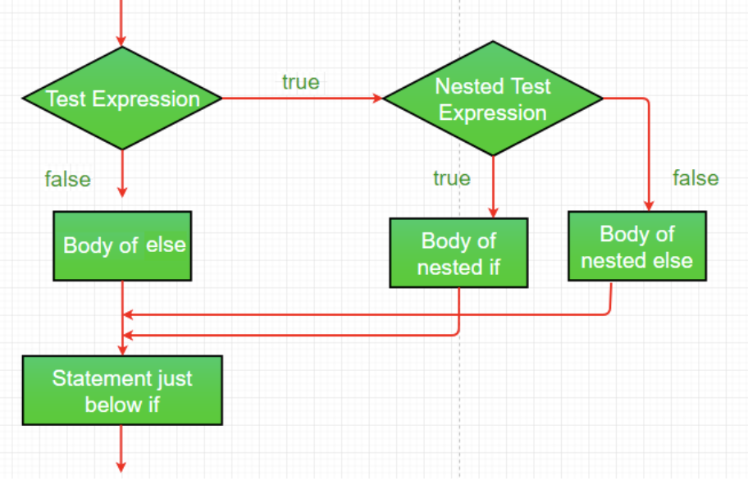

if (condition1)

{

// Executes when condition1 is true

if (condition2)

{

// Executes when condition2 is true }

}

**Switch-case**